**Module 6 Final Project — Optimization Models: Transshipment, Risk Minimizing**

Sourabh D. Khot (ID 002754952)

College of Professional Studies, Northeastern University

ALY 6050 Introduction to Enterprise Analytics CRN 81180 Spring 2022

Professor Azadeh Mobasher

Jul 1, 2022

**Table of Contents**

Introduction 3

Analysis 4

Part I: Rockhill Shipping & Transport Company 4

Case 1. Plant to Disposal Site Direct Shipping 4

Case 2. Using Intermediate Shipping Points 6

Part II: Investment Allocations 9

(i) Optimal allocation of $10,000 9

(ii) Return vs. Risk Relationship 10

Conclusion 13

References 14

# Introduction

I will be playing two roles in this project. In my first role as a manager of the Rockhill Shipping & Transport Company, I am negotiating a new shipping contract with a company named Chimotoxic for transporting chemical waste from six of their plants to three waste disposal sites. As the waste is hazardous, I have to consider only the safer routes and account for all the costs. I know the cost of feasible transportation routes between the plants and sites. Knowing the amount of waste generated per week and the capacity of the disposal plant, I will determine the optimal route for the minimum cost of transportation. Optimal cases of both direct shipment and intermediary points will be assessed. This will help me in formulating the contract.

In my second role, I am a portfolio advisor to an investor. The investor has an available fund of $10,000 and wants to invest it between six different asset types, from stocks to gold. The investor is risk-averse and has a baseline expectation of an 11% return. Knowing each asset type’s historical return and risk, I will recommend an optimal portfolio mix for minimum risk. Also, the investor is interested to know the marginal risk for an increase in expected returns. I will evaluate the risk for different baseline returns, estimate its relationship and demonstrate the risk-return trade-off to the investor.

# Analysis

## Part I: Rockhill Shipping & Transport Company

There are six chemical plants, viz. Denver, Morganton, Morrisville, Pineville, Rockhill, and Statesville, denoted as A to F respectively, and three waste disposal sites, viz. Orangeburg, Florence, and Macon denoted P, Q, and R, respectively. I have the data of waste generated per week in every plant and the disposal capacity per week of the sites. Using historical data and with the help of domain experts, I know the cost of shipping a barrel of waste for each combination of plant to plant, plant to site, and site to site route.

Determining the optimal route and quantity to ship the waste from plants to sites is a transportation problem of linear programming that I will solve as the first case. However, shipping directly from some plants to any site may be more expensive than shipping from plants to an intermediate point and then re-shipping to a disposal site. The intermediary point may be another plant or another site, whose holding cost will be borne by the customer. This will be a transshipment problem that will be solved as the second case. I will build both the models in Excel and use the Solver add-in with the Simplex LP method to arrive at the optimum solution.

### Case 1. Plant to Disposal Site Direct Shipping

Possible direct shipping routes are every combination from A-F to P-Q. Let Xij denote the barrels of waste transported from i to j and Cij denote its cost per barrel. We also know the waste generated by each plant every week and the capacity of disposal sites. The generated waste in each plant must be fully removed and supplied to the disposal sites without exceeding their capacity. Hence, the linear programming formulation will be as follows.

***Minimize:*** Z = ∑CijXxij; i = A, B, C, D, E, F; j = P, Q, R ***Subject to:*** *(1) Weekly waste shipped = generated for each plant*

∑XAj = 45; ∑XBj = 26; ∑XCj = 42;

∑XDj = 53; ∑XEj = 29; ∑XFj = 38

*(2) Weekly waste received ≤ capacity of each site*

∑XiP ≤ 65 ∑XiQ ≤ 80 ∑XiR ≤ 105

*(3) Non-negativity of every* Xij

In the Excel model, the non-negativity constraints are not explicitly formulated and are taken care of by selecting the corresponding option in the Solver dialog box. The model formulation is given in figure 1 with the optimal solution highlighted in green.



*Figure 1. Direct Shipping Transportation Model with Optimal Solution*

In this solution, the entire waste generated by each plant is transported every week, and the waste received by each site does not exceed its capacity. The transported numbers are non-negative, and the total waste shipped from plants is 233 barrels, equal to the total waste received by the plants. Hence, the solution satisfies all the constraints and is valid.

As per the solution, every week, from the Denver plant, we should ship 36 barrels to Orangeburg site and 9 barrels to Florence; from the Morganton plant, ship the entire 26 barrels to Macon; from the Morrisville plant, ship the whole 42 barrels to Macon; from the Pineville plant, ship the full 53 barrels to Florence; from the Rockhill plant, ship the 29 barrels to Orangeburg only; and finally from the Statesville plant, ship the waste in two parts with 18 barrels to Florence and 20 barrels to Macon. The Orangeburg and Florence sites are operating at full capacity, while Macon has a slack capacity of 17 barrels per week that may be used in the future. Assuming one weekly shipment between two points can handle the required quantity, there will be a total of 8 shipments. This leads to a total minimum cost of $2,988.

### Case 2. Using Intermediate Shipping Points

Designing a transshipment contract with intermediate shipping points is complicated. However, since the customer bears the holding cost, this may lead to a lower minimum cost than direct shipping, possibly due to established cheaper routes between specific plants to sites. The intermediate shipping points can be any of the plants or sites. In this formulation, possible routes are any combination of A-F, P-R to any combination of A-F, P-R (except with itself), taking care that waste sent to an intermediary point is also shipped out to a site not exceeding its capacity.

There could be two types of shipment, one from the origin plant to an intermediary point and another from an intermediary point to a destination site. For simplicity, from one point to another, a single decision variable captures the sum of both shipment types. The chronology of shipment within a week is not considered, as the solution will be recurringly implemented weekly. For instance, xAP denotes the total waste shipped from A to P, irrespective of whether the waste was generated at A or was intermediatory dropped at A. The net waste shipped out of a plant is computed as the difference between the total waste shipped out from the plant and the total waste shipped in. Similarly, net waste received is total waste shipped in minus total waste shipped out. The mathematical formulation of the problem is given below.

***Minimize:*** *Total shipping cost from all combinations*

***Subject to:*** *(1) Net waste shipped out from plant is equal to generated in that plant*

*(This also takes care of intermediary waste received by a plant is shipped out)*

*(2) Net waste received at sites is less than their capacity*

*(This also takes care of intermediary waste received by a site above its capacity is shipped out)*

The comprehensive model is given in figure 2. To avoid getting invalid routes such as sending waste from disposal site to plant, or routes with the same source and destination, I have allocated an arbitrarily high cost of $100 per barrel for such routes.



*Figure 2. Intermediate Shipping Transshipment Model with Optimal Solution*

All constraints are satisfied. The transshipment formulation has a total cost of $2,674, which is indeed lower than that of the direct shipping formulation by $314. As observed, none of the disposal sites are used as intermediary points since no waste is picked from the site and the waste shipped to these sites is not more than their capacity. Like the direct shipping case, only the Macon site has a slack capacity of 17 barrels per week that may be used in the future, while the other two sites are running at full capacity. Assuming one shipment per week between two points, there will be a total of eight optimum shipments per week, the same as in the direct shipping case. The total shipment, including intermediary shipments, will be of 331 barrels, while the net shipment from plants to sites is the same 233 barrels as expected. For clarity, the required number of total barrels, including intermediary shipment, transported each week from a source to a destination is summarized again in figure 3.



*Figure 3. Intermediate Shipping Transshipment Optimal Route*

We observe that there is no direct shipment from Denver and Pineville plants to the disposal sites because those routes are expensive, and it is cheaper to first ship the waste to Morganton and Rockhill plants and then to the disposal sites.

Since the total cost of the intermediate route is lower than the direct route by $314 (10.5%) at the same number of shipments, I will recommend the intermediate route for negotiating the contract for safe transportation at a lower cost.

## Part II: Investment Allocations

As a portfolio advisor, I have to advise the investor for the optimal allocation of funds between six chosen asset types, each with an expected return and risk (variance, covariance), for a minimum baseline return. Also, I have to derive the optimal portfolio return-risk relationship if they want to know the level of risk for increased returns.

I will formulate this problem using the Markowitz Optimal Portfolio model, which is a (non-linear) quadratic programming problem. I will build the model using matrix form in Excel and use the GRG Non-linear method of the Solver add-in to arrive at a solution. The notation definition and mathematical formulation are given below.

xi = fractional allocation to ith investment, where i = 1 for bonds, 2 for high tech stocks, 3 for foreign stocks, 4 for call options, 5 for put options and 6 for gold

x = 6x1 matrix of xi xT = transpose of matrix x

σ2 = risk or variance of the portfolio Σ = 6x6 symmetric covariance matrix µ = expected returns of the portfolio µb = minimum baseline expected return

***Minimize:***σ2 = xTΣ x

***Subject to:*** *(1) Exp. return of portfolio ≥ baseline return,* cTx ≥ µb

*(2) Exhaustiveness of portfolio allocation,* sum(xi) = 1

*(3) Non-negativity of portfolio allocation, xi ≥ 0*

### Optimal Allocation of $10,000

Solving the model with a baseline return of 11%, we can get optimal fractional allocation to each asset type, which we can use to determine the optimal allocation of $10,000. The model built with the optimum solution is demonstrated in figure 4.



*Figure 4. Markowitz Optimal Portfolio with Optimal Solution at µb of 11%*

The covariance matrix has positive values along with the diagonal elements. It is made symmetric by replicating the same values from the top right half to the bottom left half for the same pairs of asset types. Hence a unique solution to this quadratic problem exists. The optimal solution in figure 4 satisfies all constraints and has an expected return of 11% (same as the baseline return) and a low risk (variance) of 0.0007. Accordingly, my proposal to the investor will be to invest $1898.04 in bonds, $1086.31 in high-tech stocks, $2708.28 in foreign stocks, $479.43 in call options, $2544.71 in put options, and the remaining $1283.23 in gold.

### Return vs. Risk Relationship

After knowing the optimum portfolio mix for baseline return, any investor would be interested to know what additional risk they should take to gain higher baseline returns. In other words, they would be interested in knowing the optimal portfolio risk-return trade-off.

To understand the relationship, we can build multiple iterations of the previous model, varying the baseline return from 10.0% to 13.5% in steps of 0.5% each time, and solve iteratively to obtain the minimized risk and expected portfolio return values. These observed optimized values are documented in table 5.

|  |  |  |
| --- | --- | --- |
| Baseline Return (µb) | Minimized Risk (r) | Exp Portfolio Return (e) |
| 10.0% | 0.00051 | 10.0% |
| 10.5% | 0.00060 | 10.5% |
| 11.0% | 0.00074 | 11.0% |
| 11.5% | 0.00091 | 11.5% |
| 12.0% | 0.00113 | 12.0% |
| 12.5% | 0.00146 | 12.5% |
| 13.0% | 0.00210 | 13.0% |
| 13.5% | 0.00350 | 13.5% |

*Table 5. Optimized values of risk for varying values of return*

The optimized expected portfolio return is nearly the same as the baseline return when risk is minimized, which means a portfolio with minimum risk at a baseline return is generally at the baseline return itself. It is also observed from table 5 that for an optimized portfolio, risk increases as return increases. The risk of a portfolio mix giving a 10.0% return is just 0.00051, while that giving a 13.5% return is as high as 0.00350. We will plot this data on a scatterplot in figure 6 to visually inspect the relationship.

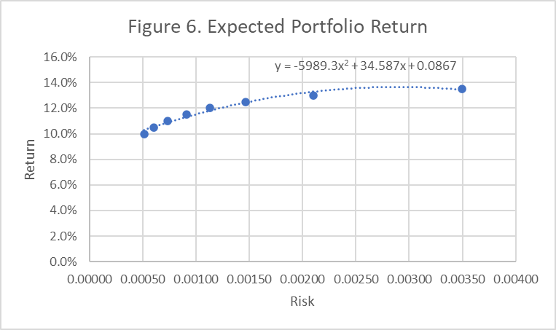

The pattern seems concave quadratic as return increases as risk increases, but the rate of increase drops upto a maximum return point, after which return decreases as risk increases. I have fitted a quadratic trendline in the graph using the Excel regression option.

The exact coefficients of the quadratic relation can be obtained using the least squares programming model as built and solved in figure 7 and plotted in figure 8.



*Figure 7. Least Squares Programming for the relationship between Return vs. Risk*

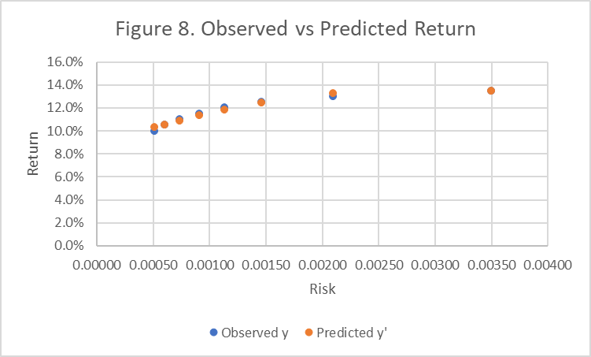

Since the sum of least squares is meager (0.00003) and visually inspecting the observed vs. predicted, we can say return vs. risk follows the following quadratic relationship.

$$return=-5989.2788×{\left(risk\right)}^{2}+34.5869×(risk)+0.0867$$

The rationale behind the quadratic relationship observed can be justified intuitively using domain knowledge. Any asset type has an inherent risk; generally, the higher the expected returns, the risker the asset. Thus, a portfolio with all low-risk assets will have a low overall expected return. As we include high-return assets, the portfolio risk increases but the expected return also increases upto a maximum point, as a balance of better-performing assets takes care of poor ones. Beyond this, even if we include risker assets, the overall return drops because there are no more stable assets to uphold the returns and balance the portfolio.

# Conclusion

As the shipping company manager, I evaluated the optimal direct and intermediary route for transporting waste, with results summarized in the below table.

|  |  |  |
| --- | --- | --- |
| Source | Direct shipping (barrels per week) | Intermediate shipping (barrels per week) |
| Denver | 36 to Orangeburg, 9 to Florence | 45 to Morganton plant |
| Morganton | 26 to Macon | 42 to Florence, 46 to Macon |
| Morrisville | 42 to Macon | 42 to Macon |
| Pineville | 53 to Florence | 17 to Morganton plant, 36 to Rockhill plant |
| Rockhill | 29 to Orangeburg | 65 to Orangeburg |
| Statesville | 18 to Florence, 20 to Macon | 38 to Florence |
| Cost | $2988 per week | $2674 per week |

Both shipping methods have eight number of shipments (assuming one shipment per week between two points can handle the required load). It is expensive to ship directly from Denver and Pineville to any of the disposal sites; hence in the optimal intermediate route, the waste from those plants is first shipped to Morganton or Rockhill plant, then shipped to the disposal sites. The cost of optimal direct shipping is $2988 per week, while that of intermediate shipping is $2674 per week. Due to lower cost and the same number of shipments, I would consider the intermediate shipping route for formulating the contract with Chimotoxic. Macon site has a slack capacity of 17 barrels per week that may be used for future planning.

As a portfolio advisor, for a baseline expected return of 11% and minimum risk, I would recommend the investor’s $10,000 funds to be allocated as $1898.04 in bonds, $1086.31 in high tech stocks, $2708.28 in foreign stocks, $479.43 in call options, $2544.71 in put options and the remaining $1283.23 in gold. This would yield them an expected return of 11% at risk of 0.0007. If the investor is willing to undertake more risk for higher returns, then I have observed a concave pattern between the return and minimized risk with a quadratic relationship given by $$return=-5989.2788×{\left(risk\right)}^{2}+34.5869×(risk)+0.0867$$

# References

*APA Style Table: APA.org*. (n.d.). Retrieved from https://apastyle.apa.org/style-grammar-guidelines/tables-figures/tables

*Canvas ALY6070: Module 6 - Optimization II (Integer and Nonlinear Programming Models)*. (n.d.). Retrieved from https://northeastern.instructure.com/courses/110059/pages/module-6-introduction

*Canvas Module 6 Project: Optimization Models: Transshipment, Risk Minimizing*. (n.d.). Retrieved from https://northeastern.instructure.com/courses/110059/assignments/1346108

Evans, J. R. (2013). *Statistics, data analysis, and decision modeling.* New York: Pearson.

*<End of Report>*